A study on Living Culture and Typo-morphology of Vernacular-Traditional houses in Kerala
Indah Widiastuti, MT
indah@home.ar.itb.ac.id
Lecturer
Department of Architecture
Institute of Technology Bandung

Abstract
Kerala traditional-vernacular houses perform refined models of tropical architecture developed within Western Ghats enclave in the southernmost part of the west coast of India. The architecture is so distinct from mainstream of high traditional Indian architectures that suggest existence of hidden indigenous tradition. In other hand, the architecture shares much commonality with Southeast Asian. Commonality on environmental characteristic with Southeast Asian, and history of maritime trading exchanges with Mediterranean, Southeast Asia and East Asia since ancient time, and European colonialism since 16th century may have been factors that enhance this eclectic blending of her nature of architecture. This paper particularly exposes typo-morphological map of indigenous-traditional-classical style observed in typology of architecture, namely: grand residential architecture of nalukettu or courtyard house; I-shape rectangular hall and buildings (Ekasala) and wretched primitive huts; Colonial villa house and other commoner’s house. The typo-morphological firstly suggest morphological relation among architectural types regardless social and cultural division that is practiced; and secondly maintain an idea of Kerala’s traditional-vernacular architecture as case of eclectic multi-cultural architecture

Introduction
This paper is written upon observation that has been taking place within 9 months in whole region of Kerala. The activities cover observation and photography-documentation of more than 50 traditional -vernacular houses in Kerala State, and 30 more random places in other states for comparisons, interviews with experts and builders. Object of study would be: patterns of settlement, building, living culture and local indigenous knowledge. Locations where samples are noted down are districts of : Shoranur, Pattambi, Pallipuram, Calicut, Palghat, Aranmula, Chenganur, Tiruvalla, Kottayam, Ernakulam-Cochin, Tripunitura, Perumbavur, Mulanthuruti, Piravom, Trivandrum, Kanyakumari, Attapadi, and Parapanangadi. From these places 52 samples of traditional-vernacular residential architecture of Kerala were taken, covering ordinary commoner’s houses, traditional courtyard house and single mass house, as well as non-Kerala vernacular houses and colonial vernacular architecture.

The research utilized methods of Typo-morphology analysis (Argan: 1965& Moneo: 1978) to examine various existing types of residential houses and their complementary. Typo-morphology mapping will be obtained to identify all possible factors that espouse the conceptualization of forms and space of the houses. Using Vernacular Matrix (Papanek:1995), the analytic categorization of types would be cross-checked by other aspects such as culture, history, social, geography to acknowledge driving forces which is embedded in the formation of Kerala’s traditional-vernacular houses and her living culture.

Conceptual Framework
Diversity of nature and culture of India has made it impossible to define Indian pre-Modern and early modern architecture as a single solid cultural entity. In other hand, due to similarity of climatic characteristic it is natural that environmental characteristic of Kerala and Southeast Asia is more comparable than with the rest of India subcontinent. Pre-Modern architecture in Kerala and also possibly other regions of deep South Asia (Srilanka, Maldives, islands in ocean of Bengal) must have been belonging to common tradition Southeast Asian architecture – wet tropical architecture.

Due to hindrance of Western Ghatz that isolated Kerala from the rest of sub-continent, the infusion of Aryan into Kerala was very recent - after Kerala developed into society of independent culture, which can be as early as 1000 BC (Logan,1887). The Aryan immigration is believed to have started towards the end of B.C. Christianity reached Kerala around 52AD by Apostle Thomas. Jew in Kerala was once an affluent trading community on the Malabar. The first mosque in India was built in Kerala when a Travancore king converted to Islam around 8th century at the same reign with the dawn of Islam/ Mohammedan in Middle East. The coming of European traders not only introduced new vocabulary to the existing tradition, but also promoted out and in Kerala from Southeast Asia. Therefore, it is seemingly obvious that subtle eclecticism had been the nature of Kerala artistic value, in which all kinds of influences, including Brahmanism were contributors to the cultural diffusion and architectural tradition. More homogeneous artistic development may have rigorously occurred around 8th century as result of large-scale colonization of Vedic Brahman, and cause the declination of Jain and Buddhism (Menon, 1978; in Singh: 2002).

Historically, Kerala was partaker in dynamic trading web of Mediterranean, South Asia, Southeast Asia and China since 13th century and much earlier, hence marking important old international seaboards, such as Calicut, Cochin, Quilon, Beypore and Crangganore. Yet, it is quite questioning, that most of the writings on cultural formation of Kerala, which is mostly referred to India, British and French sources (Logan, 1887; Menon, 1911; Singh, 2003), tended to relate Kerala’s historical narration and foreign influences with western ward places only, such as Persian, Roman, Greek, Jews, Arabic and other Mediterranean and Western Indian. William Logan (1887, pp.261) in “Malabar Manual” only reported contacts of Kerala with Chinese around 145 AD, but did not further explain how the contact were elaborated with countries in between. Admiral Zheng from dynasty Ming were reported boarding from China to Srilanka and Calicut, as well to Indonesia, Malaka and Assam around 1555 for trades. China influences in domestic day-today living are also obvious in some names of domestic utensils, such as: cheena chatti (cooking utensils made of cast iron), cheena bharani (big jar made of china clay, introduced by Chinese), so as to suggest cultural exchange of Kerala and China.

Yet, author personally experience observing old sketches in Kerala’s Museum titled “Chinese market” which was obviously picture of Surakarta Palace in Java. This case is giving a hint that the discourse of cultural indebt ness of Kerala to China and Southeast Asia is not yet as well elaborated, as that indebt ness of Southeast Asia to India explored by Coedes (1963).

In other hand some evidence has confirmed that the vocabulary of Kerala domestic architecture has inevitably shared basic form with tradition of Southeast Asia. Bruno Dagens (1994) suggested that South-Indian architecture partially inherited Pre-Angkorean influences. In the translation on Mayamatam Dagen took Kerala’s architectural construction and design plan to model the South-Indian design. Records of houses found in temple relief depicting villages of Majapahit in relief at Sukuh temple (10th – 11th AD) East Java, and Dongson’s drum Vietnam resemble closeness to typical of current and surviving traditional-vernacular roof-houses in Kerala. The ornament of window grills found in many places in Kerala’s houses is very much alike with those petrified window and doors of Bantey Srei temple of Cambodia. Bent-roof has been archetypical Southeast Asian house, since ancient time, which is also found in Kerala. Kerala’s lock’s door is also so much alike with those used in Javanese and Sumatran house. Sree Padmanabhapuram palace exhibited eclectic style of China, Southeast Asia, India and European style. These brief and early references were demonstrated the contemporaneous of Kerala traditional-vernacular house with traditional-vernacular houses from her eastern ward world.

I. Kerala Traditional Dwelling Culture
Kerala is a state of India in the most Southern tip of sub-continent which shared environmental characteristic with Malaya and Pacific archipelago, such as wet tropical climate, average 25⁰c-28⁰c temperature. Kerala is popularly called Malabar which contain eclectic phrase that means land between Mountain – Ma (Sanskrit) - and Sea- Bar (Arab). The ranges of mountain block North-Eastern wind that flow from Arabian Ocean to mainland of India. It causes frequent rainfall and left the opposite regions – Tamil Nadu - as dry shadowed rain plain. In between boundaries of mountain and ocean has been being a strip of fertile midland blessed with high rainfall and rich biodiversity to constitute predominating wet agriculture living culture. Here, units of culture that depend on river were developed and constituted agriculturist community. Each social unit became principality that resulted feudal organization. Matrilineal culture was mentioned to develop due to perpetual conflict among the other. Paddy cultivation was largely undertaken alongside the river banks by the expanding Brahman settlements in Kerala. Necessary labors were taken from inferior caste. In the old time, a Brahmin family could occupy land and as much as 6000 acres land, where they can put their sole courtyard house (Nalukettu -Malayalam). The nature of midland economy favored the emergence of isolated communities, each limited to minor watershed defined by the buttresses of the ghats and small river. This is reason Kerala midland settlements do not reflect strong urban culture, akin to typical of concentric geometrical arrangements and line house-street formation as general characteristic of Tamil settlement (Logan, 1887). They are mostly scattered individual houses or mansion compound stand upon breadth of paddy farming landscape performing “gardenlike landscape” village – ekakudumbaka-gramam- (Thampuran,2001). It is difficult to find where a village or town begin and end because houses are spread.

In selecting exact spot for this kind of dwelling a Malayali (people of Kerala) is guided by a simple rule. The garden in which house is to be placed must be intersected into as far as possible equal portions by lines running due north and south and due east and west. Four divisions of plot are thus formed, where the exact spot where the padinyatta-pura (= padinjatini/ western hall) is to be placed is in the northeast division of then plot, coinciding with the inner corner or south-west angle of the division (Singh,2003;pp.84). These midlands agriculturist living culture has becoming representative model of environment of Kerala, where most of popular representation of domestic architecture such as nalukettu laid here.

Geometrical arrangements for settlement are only started to be found in royal compounds and temples yet, overwhelmed in rural greeneries and near major river. Sree Padmanabhapuram palace, Sree Valabha temples, Sree Padmanabhaswamy temple, Pandalam palace, and Tripunitura royal compound shows typical geometrical and dense composition, familiar to classical and regional treatises. These may be obvious since Kerala’s royal community inherited royal tradition of Dravidian Tamilakam.

Yet, in particular there are many other contextual regions where diversities of vernacular huts occur, even though not as grand as the mid-lander’s. High ranges are home of earliest population who were either indigenous or settle there to escape incursion of later immigrants. The inaccessible habitats sustain their culture for long time. Waynad and Attapadi are places in hilly area of North Kerala dotted by unique folk’s settlements – mostly associate with “Irrulla” tribe (adivasi). The structures of settlement are typically arrays of single nuclear family house, standing in rows toward river or sea backed by hills or higher land. In between settlement near river bank in hilly areas is their field cultivation, or working plain where villagers takes their cows or fisherman prepare their boat and fishing equipment. These people are possibly remnant of Proto Austroloid which once inhabited Pre-Dravidian environment. Structural arrangement of communal institution are not hierarchically governed by royalty or priest, but organized by member of representative councils consisted of a prime chieftain (Oorumoopan), secretary (Kuruthalada), logistic officer (Bandhari), and seed manager (Manukaran). Accordingly valiyaveedu (Community hall) was once an important institutional building that hosted communal assembly, not necessarily temple or palace. This kind of institution is comparable to Malayan villages and traditional villages in Indonesia.

Along the coast, the scene was entirely different. The product of Kerala domestic cultivation attracted trade from far away land. Foreign influences in religion, language and art forms shaped the culture. The economy of the coastal life shows different pattern. They are more conglomerative and interdependence than the rest of Kerala. International trade contacts centered on natural ports and anchorages around which sprang up towns, headquarters of the governments.

Kerala is socially mentioned to have only three caste category which acknowledge absence on Veicya caste. Yet this idea seemed to base on narration of Hindu and agriculture tradition as predominating living culture. These narrations did not greatly consider immense roles of social development in coastal area which were developed by traders and depend on their life on maritime trading hub and fishing. They were roaming around coastal, backwater and river canal. Yet usually these people belong to non Hindu Malayali or foreign culture, such as Gujarati, Kongkani, Jew, and Arab. Some of their settlements took alien forms from Kerala type, such as those found in Cochin and Matancheri Central Kerala. In Thazhatangadi Theruvu district of Kottayam there is a traditional strip of canal-settlement with couple rows of traditional-vernacular of houses facing Meenachil river and boulevard flanking both side of the river. These strips mostly belong to traders and merchant whose religions are Islam and Christian Syrian. The house types are popularly considered as Christian Syrian house and perform eclectic vocabulary of Kerala, Southeast Asian, and Portuguese style. Sea shore settlement showed the most extreme eclectic features rather than inland Kerala, especially around ancient trading port.

1I. Types of Houses: Veedu
House in Kerala is generally called Veedu. Veedu give shelter to joint-family kinfolk or tharavad. Joint family system (tharavad- kinship system) consequently brings forward tradition of living in huge shelter and or mansion (veedu- object of house). The term is Dravidian and is used in some parts of Tamil Nadu and North Srilanka for all types of residential architecture, but practically people of Kerala will address their veedu as tharavad. However courses of domestic architecture in Kerala are diverse. Particularly tribal people have more various addressing for houses or huts according to locality, social status and structural types. Observations on proper traditional-vernacular house came up with five types of spatial structures of house.

For tribal community although veedu is a very common vernacular term for house, there are actually various terms of house for different tribes according to social status and proffesion. The house of Pariah is called cheri, while the agrestic slave-Cheraman – lives in chala. The blacksmith, the goldsmith, the carpenter, the weaver and Toddy drawer inhabit house called kudi; temple servant resides in a variyam or pisharam or pumatham. The ordinary Nayars stayed in Vidu/ Veedu or bhavanam, while the Nayar’s authority dwelled in an idam. Raja lives in kovilakam or kottaram. The indigeneous Brahman (Nambutiri) in an illam, while his fellow of higher rank calls his house a mana or manakkal (Iyer:1968 in Singh,2003).

There are various structural types for residential structure for different tribes (Iyer:1968 in Singh,2003). Cave dwelling were found in Cholanaickan tribe. Each houses of a nucleus family were demarcated by hearth. Lake dwelling and three huts were also once found plentiful surrounding backwater. Forest dwelling people tend to settle in hamlets comprised of closely-related individuals, each of them prefer individual homestead.

There are five types of spatial structure of traditional domestic architecture or Veedu in Kerala, notably: (1) wretched humble houses -unknown by any building’s treatises of Kerala - belongs to ordinary folks, and tribal people/ adivasis (cheri, chala, kudi, variyam or pisharam or pumatham); (2) Ekasala (I-shape single rectangular hall houses belongs to farmer folks houses or mid-class non-farmer’s folks); (3) Nalukettu (courtyard houses, belongs to landlords); (4) Great mansion of Ettuketu (double nalukettu), Patinjarukettu (double ettukettu) or much bigger kinds, belongs to very rich landlords. Commoner houses (5) are simple ordinary houses, scattered abundantly in the cities and villages. They still show applications of traditional construction and vocabulary in eclectic, popular and free manners.

Literally, local term of house – veedu- means simply home, and signifies no importance of any structural arrangements. Classical Indian architecture acknowledges concentric arrangement of building and generic spatial structure of sala or hall. Ekasala means single hall house, dvisala means two-hall house, trisala means three-hall house, and catusala means four-hall house/ courtyard house. Nalukettu is the only local term for house that imply structural importance that associate with catusala. There area no local term for dvisala, trisala and ekasala, for that they are simply called veedu. Muslim’s house and Christian Syrian house are also simply veedu, even though they can be a big mansion and having courtyard. Most probably the importance of extensive development of nalukettu follows the significance of reference toward traditional-classical treatise; while the indigenous-vernacular extensive developments of houses/ veedu are not necessarily refer to it. More numerous numbers of I-single veedu than nalukettu as observed by Thampuran (2001) may explain the degree of its vernacular aspect of ekasala veedu than nalukettu. This may lend base to an understanding that concept of single hall house/ veedu is general and generic.

Like most houses in Southeast Asia, spatial and functional difference of domestic activity and spaces were housed in different hall or space, not room. Seeing the tribal compounds, they always put fireplace or cooking area and washing in separated hall or corners, so as to constitute compound of different functional hall and exterior living. The same pattern is also attributed by mid-class ekasala veedu, where kitchen would be always placed separately, but at times connected by porticos. Forest dwelling tribes like Muthuvan and Urali Kuruman always have Valiyaveedu (community hall). Community hall in Southeast Asian architecture is very essential to note democratic and communal governance.

2.1. Single Hall House
Generally house structures in Kerala are single hall house. Only later this single hall is partitioned to perform interior partition. Wretched huts and hamlets mostly are individual small huts consist of only one hall but divided into inner and living spaces by means of temporary structure divider. One single hall house is also still found in high class society such as case of Amma Veedu in royal compound of East Fort, Trivandrum.

Type of single hall huts can still be found in interior villages, seashore villages and even vernacular houses in the city. The houses are usually small and are erected on ground level, sometime on raised platform. The materials are locally available: bamboo reeds, wooden poles, mud and local grass or leaves. The walls may be of a wattle (bamboo splints woven together and covered with a mud plaster) and are sometime decorated with red or white mud stripes. The door is protected by sliding screen made of plainted bamboo. The roof is of wooden poles, bamboo and reed and is thatched with grass. Rounded or pyramidal-shaped roofing is also constructed occasionally among traditional Kullu and Kuruman huts and the Kurumba Pulaya for Thennesveedu or menstrual hut. Their settlement always appears as clusters of houses standing in rows facing water sources (river, lake, backwater, and ocean) and backed by mainland or mountain. Huts are somehow still available in the city, regardless social status, thus marking availability and practicality of its construction. In south Kerala huts could be unique for its bent roof shapes.

Spatial division which is found in both huts and the more middle class elaborated single mass house are basically originated from one hall house. The hall can be arrayed and constituted row of halls for different functional space with veranda, or divided by divider to constitute into arrayed inner rooms. The observations shows that three arrayed rooms are the most frequent spatial structures that appear in single hall houses. The rectangular single hall, with sitting platform attached is made of laterite stones or hardened mud, plastered with a mixture of mud and cow dung. Superstructures are made of wood planks. Later additional space were added to the three arrayed rooms to appear additional gallery that back the rooms, thus performing imaging of 9x9 spatial grids. Three arrayed rooms and 9x9 spatial grids thus are becoming archetypical of spatial partitioning and division of single hall. They have been a schemata of traditional-vernacular applied for any commoners houses.

2.2. Ekasala/ Structure of Farmers House: importance of Ara-Kalavara
As farming is the major lifestyle, grain store becomes important designations to maintain. The grain store designs vary from a small box (pattayam), in house grain store room (ara) and in house of grain storage and treasury building (pattayapura/ pathayapura).

Agriculturist or ekasala house attributes the typical single hall partitioned in three arrayed rooms enriched or fronted by gallery/veranda. The middle room is thus regarded the most important part which is utilized as ara. Ara is standing on 4-5 feet above platform. Ara or the grain store is becoming the very soul of the house put in the middle room, and is considered sacred. The two other rooms flanking ara are called Kalavara. The structure of three-room-arrays and kalavara-ara-kalavara prevail abundantly in villages and cities. These are multifunctional rooms which could be used as bedroom, storage or treasury. Beneath Ara there is semi basement storage room called nilavara.

Ara has two doors which face interior for daily use and the other side that face exterior or rare gallery / passageway to get the paddy in. In any house arrangement, ara-kalavara would be put in either western quarter (padinjatini) or southern quarter (thekkini). Door of Ara open to the east while nilavara (semi-basement storage) open to the west. Typical structure of one ara flanked by two kalavara, and nilavara beneath are becoming typical basic package of peasant house. In the morphology of nalukettu, ekasala posited on one quarter of the fourfold hall, usually situated either in western quarters or padinjatini or southern quarters or thekkini. In cases of ettukettu and patinjarukettu, the salas would be multiplied towards northern ward and or eastern ward, where ekasala with ara would still be put in either west or south. Existence of ara and nilavara emphasizes the role of paddy farming living culture that governed the traditional ekasala of Kerala.

2.3. Nalukettu and Nadumuttam
House of Brahmin, landlord and royalty takes type of courtyard mansion called nalukettu (nalu=four; kettu=hall- Malayalam; Catusala - Sanskrit). Courtyard house has been a fashionable and well-known typical houses in India. Courtyard house in different place has their name. It is Haveli in North India, Wada in Maharasthra, Rajbari in West Bengal, Deori in Hyderabad, Cathurmukham in Tamil Nadu, and Nalukettu in Kerala (Rhandanawa: 1999; Anand: 2004). Nalukettu has been popular representation of Kerala’s traditional domestic architecture.

Nalukettu can be multiplied to make double nalukettu with two courtyards (ettukettu) and fourfold nalukettu with four courtyards (patinyarukettu) following needs of spatial extension. The plan or spatial boundaries for certain designations are mentioned to follow patterns that are prescribed in Vastu. North and East are given foremost importance, therefore family temple, and any religious relics are put here. Ladies room is usually put in north facing south. Entrance can be alternatively in Southern or West corner.

Subject of courtyard house is apparently more complex than nalukettu. South Kerala traditional courtyards have different morphology as those belong to North and Central Kerala. South Keralan spatial division doesn’t follow strict concentric arrangements as those of North and Central Kerala. South Kerala nalukettu perform more extensive single hall with courtyard-like inner opening, and North Kerala nalukettu as concentric multiplied sala encircling courtyard. In North and Central Kerala, courtyard can be very wide and used for various activities, but in South Kerala the courtyard are usually very much small, and works better as water cistern. The activities in South Kerala’s nalukettu are mostly not conveyed in the enclosed interior but in open layout hall among courtyard, blending with circulation. Ara-kalavara, pooja/ prayers alcoves or rooms and kitchen are the only enclosed space posited in one or two quarters of the courtyard house. On the contrary, in North and Central Kerala spaces around courtyard works generally as circulation that leads to the four-hall rooms. North and Central Kerala’s courtyard plays some functional activity like drying rice, water cistern, garden, or children playground, while in South Kerala, spaces around courtyard work as living spaces. Thampuran (2001) marked that courtyard for arrangement of South Kerala nalukettu are simply consequence of structural difficulties and needs for lighting and water cistern. She regarded South Kerala open oplay-out nalukettu and nadumuttam (courtyard) as basically single hall structure with opening in the middle of space (mandapam – Thampuran; 2001). She regards this type as more ancient and original.

According to Thampuran there is also courtyard house structure that is impropriate to be mentioned as nalukettu, thus is regarded as pseudo-nalukettu. Acording to her a nalukettu must have 4 comparable roof scales. When one quarter is much bigger, the rest quarter is regarded as extension and is called kuttikettu. This is obviously in houses at Allepey, Kottayam and houses of people of Christian Syrian houses in districts Thazhatangadi Theruvu of Kottayam- South Kerala, where courtyard happened to appear as technical consequences of creating annex building linked by two parallel rooms or passageway, and leave void in between buildings. This is also said to be consequence of functionalism brought by Western missionary.

2.4. Eclectic Design of Villa, Muslim’s Veedu, Christian Syrian house and other House
Comparing to midland, coastal cities and villages reflect more eclectic culture. Muslim, Christian, Jew, China and Konkani, as well as Portuguese, Dutch and British left traces of their artistic style and structural form to the native houses. Hindu in north Kerala coastal districts are seconded by Muslim, and Southern coast of Kerala are by Christian Syrian. Typologies of Kerala’s traditional-vernacular residential houses were partially or as whole taken as referent for stylistic adoption. The aspects which I still obvious showing ingenuity of traditional Malabar domestic architecture are basic form of single hall, hipped, shingle roof, mukhapu (gable), three arrayed room arrangement.

Cochin is becoming melting pot of eclectic villas, mansion and palaces. Cochin and Quilon had recorded as active seaboard since 1000BC bounded by Trans Mediterranean-China maritime trade contact. European-Indies design, Portuguese arches, solid and fort-like structures are intermingling with stereotypical of Kerala wooden wall (nira), and mukhapu (gable), intriguing bent roof shapes. Had it been earlier reached Kerala, Portuguese even brought influences to Kerala’s traditional houses, so that many Kerala’s traditional houses attribute Mediterranean arches and Classical posts. Sree Padmanbhapuram Palace is the most representative expression of traditional eclecticism that happened in Kerala.

Eclecticism also happened in spatial formal structure. Distinguished spatial structure appears such as in Kuttikettu (pseudo-nalukettu) and European-Indie villa, in which the spatial arrangements are more functional and organic, loosely referred to Vastu but still vaguely perform remnant of three-arrayed room. British architect tried to synthesis mix-style of European-Kerala design obvious in Napier Museum, Bolgaty Palaces and University of Kerala. British architects attribute physical characteristic and ornaments of Kerala ekasalas but still keeping stereotypical of symmetrical Classical rotunda spatial lay-out. In Napier Museum they even performed sharp eclectic interface of interior-exterior for which the interior was designed in Moghul style and mix-Western Classical-Kerala style for interior. In other hand, Dutch showed more consistency to typology of house as a whole, in adopting both layout and expression of the Malayali ekasala for Bolgaty palaces. He only made obvious difference in scale, structure and attaching Classical elements such as Roman portico. Palaces architecture was influenced by the Dutch Palace, originally built by the Portuguese at Matancheri. Hindu temples and early Mosque were in the basic Kerala style; churches were rebuilt in the Portguese style, but in some particular cases, mixed with Kerala’s spatial element and ornaments.

With increasing density of population the dense row house run linear sprawl and turn Kerala into image of urban living. Commoner local villa houses are available in all places in villages and rural Kerala, and they are of most numbers of Kerala’s vernacular architectures, and perform intriguing eclectic style. Portuguese Mediterranean arches and, Burmese and China ornaments, Southeast Asian bent roof, Dutch functionalism, European Classical column, and British Victorian Style added the richness of Kerala houses. Secondly, they reflect equilibrium of mix modern and traditional style which still endures present modern living culture. They have typical of modern structural mass, which sustain characteristic of roof design. There are 4 types of masses: an I-shape rectangular house which is of most frequent appears, L-shapes, C-shapes and square shape buildings. There are also three types of roof gesture, which are bent roof with gable at the ends of ridges, hip roof with gable at the ends of both ridges, and pure hip roof. The layout could be organic, but mostly still follow three arrayed rooms’ arrangements.

2.5. Roof Construction
Roof in Kerala houses reflects outstanding feature of shingle and bent roofs construction. It reflects logic of tropical sloping, shingle, hip, saddle roof and span of eaves of the roof slopes. “Roof as crown” has been a metaphorical saying for architecture in Southeast Asia (Roxana Waterson: 1990). The advent of mukhapu (-Malayalam) and bent roof design may not found comparisons in India itself but typically abundant in Southeast Asia, notably Malaysia, Minangkabau, Batak, Java, Thailand, and even Vietnam. Kerala’s roof is likely belonging to old traditions. The replica of rafter construction has been found Kanchipuram and Tanjavur, South India temple which were date back to 12th century. But the whole roof shape is of similar with depiction of Majapahit villages depicted in relief of 13th century temple. Responds to sun light’s glare is shown by the frequent uses of latticed windows, applied in the most humble houses, landlord houses up to also royal palaces.

Kerala’s roof structures perform 3 dimensional space frames. The basic structural elements consisted of pairs of kazhukol (rafters) rested on uttaram (wall plate). Pairs of kazhukol will meet at montayam (ridge) to make hipped roof. Pairs of kazhukol (rafters) would be bounded wholly by horizontal rods going through arrays of pairs of kazhukol. This rod is called vala. Thus, vala, kazhukol, montayam and uttaram become one unit of roof construction. The course of vala performs roof construction of Kerala as 3 dimensional rigid space frame. Expressions of Kerala’s roof construction present various designs of pitched gable or mukhapu, especially in South Kerala. It seems that kazhukol-vala construction was originally simple rope-tied construction which is usually utilized in humble bamboo huts. This pre-thesis is strengthened by some sources that mention that in the ancient time, nalukettu is constructed out of bamboo.

Another interesting feature is a trapezoidal construction works that looks like main arch structure in wooden truss system of Gothic architecture, called Viskhamba. For narrow span hall, roof construction needs only a pair of rafter (Kazhukol) tied on top by one ridge beam, both ends rest on wall plate (uttaram). Both Kazhukol (rafter) are usually stiffened by a longitudinal beam, and longitudinal stiffener that clamp both kazhukol, called valabandam. When the hall span is getting larger, the pair of kazhukol needs stronger longitudinal beam, thus the original linear longitudinal beam was elaborated into arch-like truss. Since it is probably difficult to elaborate wooden arch, the structure turn out trapezoid. Main horizontal structural support Uttaram will be divided into two layers. First layers rest upon lower uttaram (varotaram) which is on the wall, and the next layer were on the trapezoidal construction viskhamba. This second or the upper layer of uttaram is called arudhotaram. Upon arudhotaram and the varotaram, kazhukols sit. It is believed that pranah (living energy) is residing in the uppermost wall plate (uttaram). A courtyard house is called nalukettu when they have continuous connectivity of the four quarters of the salas.

III. Typo Morphological Analysis
3.1. Typo Morphological Mapping
The typo-morphological mapping of house plan in diagram 1, show that the most basic spatial shelter structure found, only consisted of hall and veranda. This typical plan is currently found in Kerala temple’s sanctum (Srikovil). Veranda is originally extended overhanging eaves that protect building from rain and sun glare as well as providing sitting area attached to the house. Later the hall was arrayed into chain of rooms as many as functional space needed, and the veranda was extended accordingly. Three arrayed room with veranda are the most stabile number of arrayed rooms that existed.

Arrangement compound of house contained patterns consisted of several single halls of different functions and activities that probably could illuminate earliest type of house which is always in context of compound. Remnant of tribal house’s compound showed that cooking spaces and living spaces are put in separated shelter as well as grain storage hall and menstrual huts. Valiyaveedu (community hall), chieftain sitting hall are standing separately among compounds acting as landmark of the villages. This kind complex arrangement also existed in more elaborated design of landlord compounds where nalukettu or veedu was supported with patthayapura (grain storage hall), pattipura (gateway and guesthouse). In nalukettu kitchen has special and important placement in north-east corner of house, but in case of commoner’s house kitchen are on the same cardinal direction but mostly standing in different hall connected by passageway. Most design of nalukettu does not have solid structure for the corner portions thus suggest Nalukettu’s mansion as not exactly a monolithic courtyard design but four halls crowned by one encircling roof that constituted courtyard.

In agriculturist family, ara (grain store) reflects the role of agriculture in shaping predominating living culture and social institutions. Ara became basic spatial structure of ekasala as traditional-vernacular peasant houses of Kerala. Kitchen is the most important room in house and also nalukettu, comparable to the sacred courtyard. This practice stood in different school of thought that usually put kitchen on the square of Agni (god of fire) in north-west corner. It is probable that beside its functional significance of domestic production spaces, the importance of kitchen is associative to its earlier and tribal form - hearth.

Other than ekasala, dual inner-living space and three arrayed unit of inner and living space can alternatively develop into other type of spatial usages, unnecessarily attributing ara, such as vernacular houses of labor, urban villa, and rural commoner’s compound.

The morphological development of nalukettu from the elementary ekasala suggests two different mainstream and traditions in courtyard house designs (Thampuran: 2001). One mainstream, which is mostly found in north and central Kerala, perform nalukettu as fourfold ekasala, arranged in concentric manners. Among four quarters hall, the most important and sacred quarter is those that contain ara-kalaavara. Proper/formal courtyard as prescribed in Vastu may only of these North and Central Kerala courtyard house. Another morphological development of nalukettu does not suggest any linier multiplication of sala but extension of hall of ekasala (Thampuran: 2001). This extensive enlargement, which is mostly found in South Kerala, performs nalukettu with very small courtyard (nadumuttam) and open lay-out hall surrounding it. Less significant scale of south Kerala nalukettu Hindu suggest that the layout is containing more indigenous value.

The structure of open lay-out living spaces and small courtyard is also amazingly found in Muslims mansion and Christian Syrian kuttiketu but not as elaborated and significant as the Hindu house. Some Muslim mansion also have courtyard but so small that even people would abandon it and function it merely as water cistern, while spaces around courtyard is what is considered significant. This exactly follow typical pattern with traditional nalukettu of South Kerala.

3.3. Eclectic Expression
Geographical positions also signify difference in expression or style. North Kerala expresses more massive appearances in latterite construction. It performs hipped roof, massive and solid laterite construction and wooden carvings and openings. Portuguese arches for windows and doors are mostly found, as well as Classical columns and capital for porticoes and veranda. Muslim’s compound usually showed particular ornaments for openings frame designs. And they are plentiful in Malapuram, Parapanganadi, Calicut and Cranganore. This may be explainable since Portuguese, Tamil and Muslims had once strong influence in North Kerala. Tamill which was once part of Madras presidency with North Kerala contributed style of Islamic Arches.

South Kerala and Central Kerala appears more light structures in timber. South and Central Kerala can be obviously differentiated from North Kerala style from its bent and or gabled ridge roof. Yet South Kerala house’s construction (in districts of Pathanamthirta, Kottayam, Trivandrum,) was lighter than Central because of more usage of woods than Central Kerala. This may be obvious since Western influences that enhance the usage of massive and earthen material were more influential in Central Kerala. Both South Kerala and Central Kerala architectural design similarly showed intriguing, eclectic style following up the mutual influences with China, Burma, and also Southeast Asia. One 400 hundreds year’s old nalukettu still perform enclosed house without window, just like they in Southeast Asia.

IV. The Role of Builder (Thatchan/ Taccan/ Taksaka)
In Kerala, the role of architect is obvious and called thatchan or taccan or builder who follow certain norms, scholarly or hereditarily passed on generation to generation which therefore have traditional base. Theoretically Indian builder are hierarchically put in four ranks according to their skill and senior ship – Sthapati (architect), Taksaka (builder), Vardakki (supervisor), Sutragrahi (labor)– where taccan theoretically is comparable to taksaka. But apparently, Kerala’s taccan appeared as all-round artists who were not familiar with such hierarchy. Even higher rank of taccan was not considered as Sthapati or master architect, but Perumtaccan or “master taccan”, or “master builder”. It was said that only later when Brahminism gain influences and especially for temple design, some parts responsibility of thatchan is taken by Brahmin, such as conducting poojas (prayers) before construction. There are some regional treatises (Vastu) available that these thatchan use for designing, namely: Manusyalaya Candrika, and Thatchusastram.

A thathcan did not only make house, but all kind of carpentry including boat. The figure of taccan can be very unique, ambiguous and plural personality. Traditionally a taccan belonged to Sudra caste, namely Ashari. Amazingly, they are temporarily considered to be a Brahmin when is involving in construction work. By the time, they are requested to be clean, vegetarian and conduct poojas (prayers). They may be for a while released from the role of untouchability and are allowed to enter house of nobility or Brahmin to work out his plan (Jayaraj: 2004).

Yet, there are a lot of exceptions to the mainstream treatises that prevail. These exceptions indicate ingenuity of Kerala builder traditions. There are two major skill of construction practiced in Kerala, notably laterite masonry and wood carpentry, yet only wood carpentry appeared in shastram or science. And even practically laterite mason or Kalaseri was considered as subordinate of thatchan or carpenters. Some probable reasons are that laterite construction and monolithic building is not deeply indigenous tradition, but brought in by Portuguese or from northern region of North Kerala (South Karnataka).

V. Conclusions and Recomendations
Basically, environmental determination mold the shelter design’s tradition. Wet tropical environment of both Kerala and Southeast Asia perform typical architecture obvious through several indications, such as:
- Shingle roofs and Protruding eaves as responds to tropical rain, wind and natural source,
- Grill window window and porous wall to respond tropical sun glare.
- Significance of rectangular I-Shape building mass.
- Open lay-out living spaces.

Secondly, experiences of observing Kerala houses evokes
- appreciation and knowledges on architectural importance of multi-cultural aspects of the traditional-vernacular architecture of India whose gestures alike those in Southeast Asia;
- they are still currently a living traditions;
- an insights of continuum relations between South Asia and Southeast Asian architectures; whose impulses may lay similarly everywhere in particular melting pots of multi-cultural influences such as South India, Srilanka, Maldives, Bengal, Nicobar and Andaman islands Lakshadweep islands and also Southeast Asia archipelago. This phenomenon performs case of eclecticism that happened in early modern history of Asian architecture;
- understanding roles of European colonialist to enforce interchange and corroborate the multiplicity of culture to South Indian architecture, as well as enriched the vocabulary of architectural style with their own style.

Thirdly, typological connection of Kerala and Southeast Asian traditional architecture could be reflected in three period of influence. A linguist- Jean Przyluski (1929) exposed how in much earlier time of Pre-Aryan and Pre-Dravidian age, people from places who inherited Austro-Asiatic language was also mentioned to once populated parts of India, noted by some common ancient linguistic gesture which is assumed to had been derived from Southeast Asia, thus suggested that India and Southeast Asia were once in bounded culture. This period belong to Proto-Austroloid stock, during pre-Aryan and pre-Dravidian India. The analysis of Kerala’s tribal architecture showed how tribal living culture in Kerala showed similarity with traditional-vernacular tradition in Indonesia, such as: non-hierarchical communal governance and acknowledgement of valiyaveedu, linier settlement, exterior living, and single hall-multifunction house. This culture sill survived in tribal villages residing in high ranges of Attapady.

Globalization of 13th-16th century had once spread through Web of Asia. Kerala and Southeast Asia has been in contact or in bound since ancient time. Generally within this schemes history of architecture in Southeast Asia is often noted as Indianized states (Coedes: 1 969). But the eclecticism that was obvious in Kerala’s architecture on the contrary suggested how Kerala also inherited some vocabulary of architectural forms from Southeast Asia. Bent and shingle roof designs, raised platform of ara, were well illustrated in depiction of house in Borobudur temple and East Java’s temples of 8-12th century from Southeast Asia.

The coming of European colonialist around 16th century brought colonialism to Asia, and consequently in one hand enhanced the architectural tradition with diffusion of European architectural vocabulary into the native tradition, and in one hand reinforced the cultural mutual exchanges of both South Asia and Southeast Asian culture through the trading and politic inter-relation. The usage of Classical architectural elements, introduction of tiles and massive construction, Victorian style and functional approach in design, refined design of openings had elaborated Kerala’s architecture into eclectic designs.

Cases of Kerala traditional-vernacular architecture enhance discourse of Eclectic architectural design before Western formalized the colonization and monopoly over Asian trade network. The architectural designs of the period suggest intermingle of culture that happened ingenuously. Multi-layer historical narration should be able to explain eclectic modes of developments as base to explain the spread and transformation of the style. Pre-European Colonialism traditional architecture of Kerala can be the case of entry of multi-cultural design morphology. Trading ports developed around 13th-19th centuries such as Cochin is probably one among very few traditional trading ports in Asia that sustain the living artifacts that survived.

As conclusion, Kerala architecture is not simply Indian architecture. Kerala architecture in general has shown cross boundary and multi-cultural architecture style and gesture. The same phenomenon may happened in other peripheral spots such as architecture along Silk Road which passes Nepal, Madagascar, or states that were one occupied by European colonialism at their own time. The phenomenon was very typical with current architecture that follows late Capitalist of present time where it is much more difficult to make difference among architectures in different nations, since popularity of International Style and Post-Modernism after post World War II. Globalization in many ways has been always altering the map of local visual experience, while exhibiting typical acculturation which could be in one hand evolves homogeneous new style or in the other hand - eclectic style.

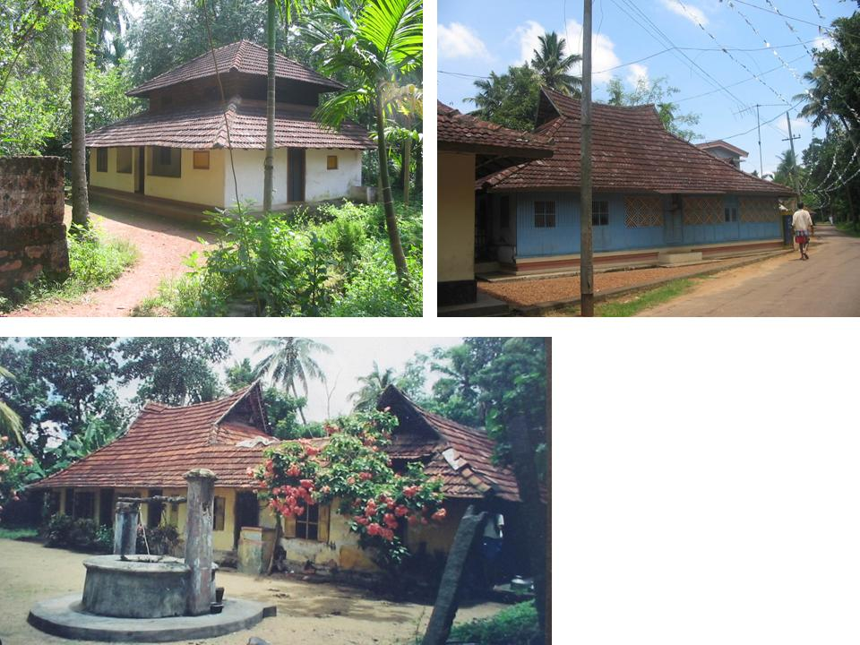 | Figure 1. Three Types of Ekasala.  (upper- left) Ekasala of North Kerala. Mostly they are shingle hipped roof house  (upper-right) Ekasala of South Kerala. Mostly they are shingle-bent roof  (bottom) Kuttikettu or Ekasala with courtyard extension  Source: Author

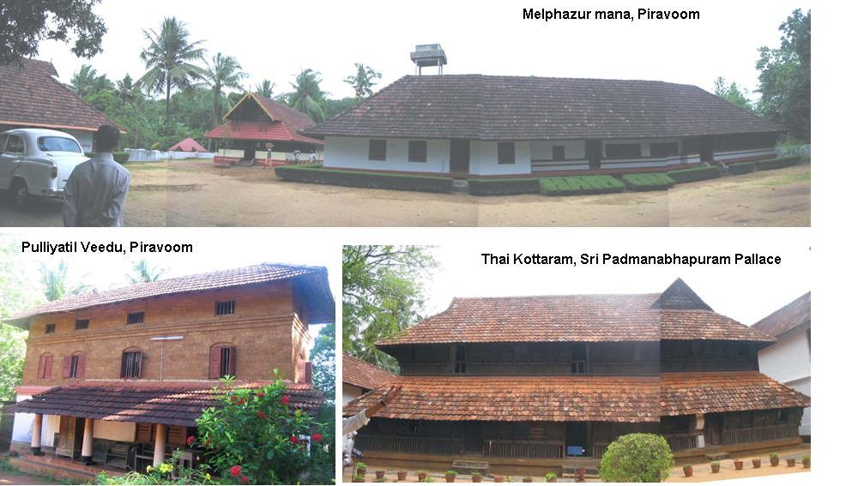
Figure 2 Three Typical Expression of Nalukettu
Central Kerala (above), North Kerala (left-bottom), South Kerala (right-bottom)
Source: Author)

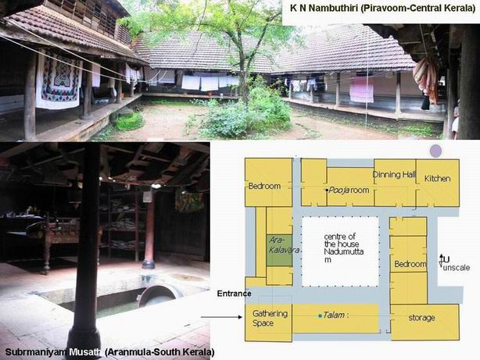 | Figure.3: Typical Layout of Nalukettu and Courtyard  Source: Author

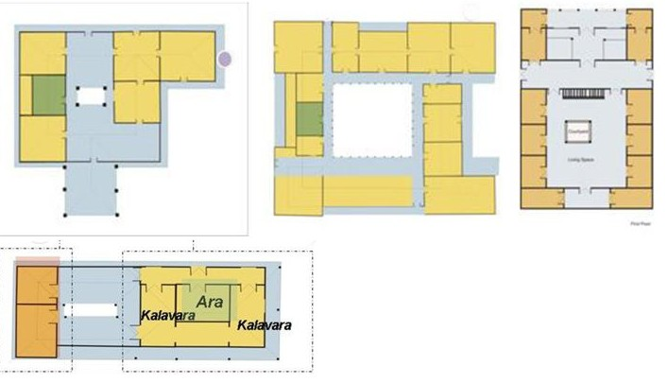
Figure. 4: Typological difference of courtyard mansion of (upper left) South Kerala nalukettu; (upper middle) North Kerala nalukettu, (upper right) Muslim;s Veedu and (bottom) of Christian Syrian Kuttekettu

The diagram show that nalukettu of the North and Central Kerala are relatively wide while South Kerala and Muslim’s mansion are small but having open layout spaces around courtyard with few room. Kuttikettu only has one sala with extension in a form of courtyard

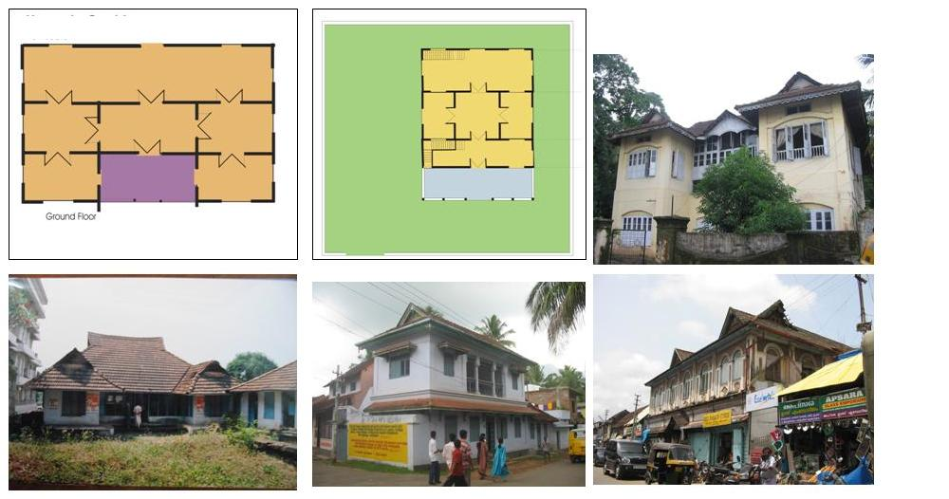
Figure.5: Types of Commoner’s House
These are outlooks and plans of commoner’s houses abundantly found in villages and urban area, which are still in use, adaptive to modern living culture but still inherit traditional vocabulary or even rules
Source: Author

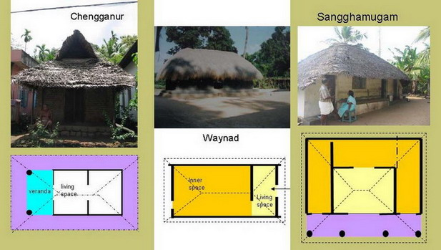
Figure 6: Three Types of Chala
All Chalas show typical spatial configurations of living and inner space.
(left) Chala in Chengganur, South Kerala; (middle) Chala in Waynad and (left) Chala in Trivandrum
Source: Author and T.S. Parameswaran

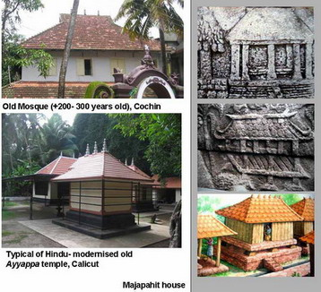 | Figure.7: Comparison of Roof design of Kerala with vernacular house of Majapahit  Vernacular house during Majapahit according to temple relief at Sukuh Temple (10th-11th century) and artistic impression taken from Negarakertagama inscription (1365 AD)  Source of Picture: Author, Made Wijaya and Indonesian Heritage

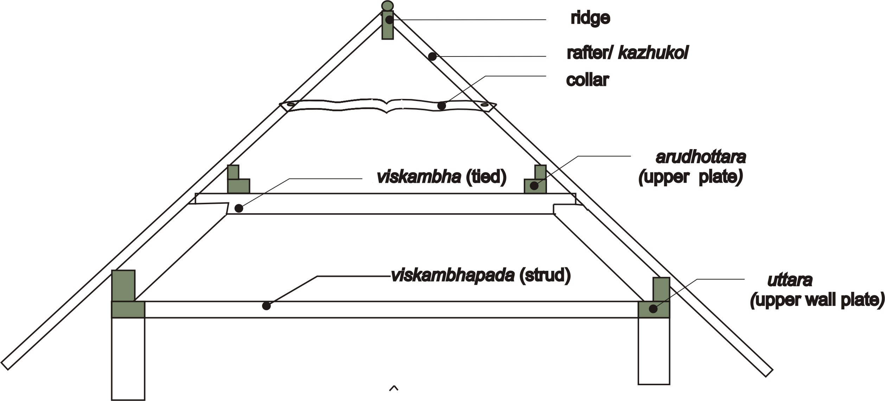 | Figure. 8: Wood construction for roof- kazhukol-vala (left) and Nira (wooden wall)  Source: Author

Diagram 1: Morphological Development of Single Hall House
The diagram show three different morphological paths of three-arrayed rooms, which are morphology of Ekasala (bottom), labor vernacular houses and Chala (left) ; and Commoner houses (far left)

Refferences
- Achyutyan A & Balagopal T.S Prabhu. An Engineering Commentary on Manusyalayacandrika of Tirumangalat Nilakanthan Musat. Calicut: Vastuvidyaprathistanam, December 1998, pp 1-267
- Argan, Giulio Carlo (1965); “On Typology of Architecture”, Theorizing A New Agenda for Architecture -–An Anthology of Architectural Theory. Princeton Architectural Press,. New York: Kate Nessbit. 1997, pp 240-247
- Coedes, Geordge; The Indianized States of Southeast Asia; Honolulu, East-West Center Press, 1964. pp.1-34
- Cooper, Illay& Barry Dawson. Traditional Buildings of India. London: Thames and Hudson Ltd, 1998 pp.11
- Dagens, Bruno. Mayamatam Vol II (3rd edition). New Delhi: Indira Gandhi National Centre For The Arts, copyright date 1994-2000,
- Mouldon, Anne Vernez, “Ordering Space – Chapter 16”: Getting to Know Built Landscape: Typo-Morphology, pp. 289
- Papanek Victor (1992). The Lesson of vernacular Architecture, in “Green Imperative”, New York: Thames in Hudson, pp. 113-138
- Panikkar, T.K. Gopal. Malabar and the Folk. New Delhi: Asian Education Service, 1900 (1st Ed), 1995 (3rd Ed). pp
- Przyluski , Jean; Sylvain Levi and Jules Bloch, (1929); Pre-Aryan and Pre-Dravidian India, Asian Educational Sercvices, New Delhi, pp.i-145
- Rudofsky, Bernard Architect Without Architect, Academy Edition, London, 1964, pp.4
- Randhawa, TS; The Indian Courtyard House; New Delhi, Prakash Books, 1999
- Sing, KS; People of India: Kerala Volume XXVII Part One. Anthropological Survey of India, New Delhi, 2002. pp.33-127
- Soejono, R.P. “Architecture”, Traditional Architecture. Indonesian Heritage Volume 6, Julian Davison (Ed). Singapore: Archipelago Press, 1998. pp. 10-11
- Thampuran, Ashalatha ; Traditional Architectural Forms of Malabar Coast; Calicut, Vastuvidyaprathistanam, October 2001, pp. 1-196
- ___________. Dakshinachitra, - A Glimpse of South India. Madras: Madras Craft Foundation, 2001, pp. 25-58
- e.g., Detailed Project Report For Comprehensive Hamlet Development – Koodanchala (8/7), Habitat Technology Group, Poojapura, Thiruvananthampuram

Untouchability is a custom inhered in caste system of India that high-claste (mostly Brahmin) is believed can not be touched by people of lower caste.
Terms of “vernacular architecture” stand for art of buildings and shelter which is spontaneous, environment oriented, community based and acknowledge no architects or and treaties, and reflect technology and culture of indigenous society and environment (Rudofsky: 1964. pp.4). Vernacular architecture is in the opposite of high traditional architecture which belonging to grand-tradition (e.g. palace, fortress, Villa and etc), and enquire special skill and expertise, for what reason, architect have special position and knowledge (Rapoport: 1969).
Mayamatam is a traditional treaties of Architecture and Settlement of India, composed between 14th-16th century, which is considered to be Dravidian. Mayamatam and Manasarm has been regarded as the most complete Indian architectural Vastu. Manusyalaya Canndrika, and Thatcushastram is special treatise of Kerala. Roof structure of Kerala is found nowhere else in India but Bruno Dagens (2000), in his translation of Mayamatam, expose Kerala’s roof structure to illustrated Indian roof construction in general.
Various studies have indicated a Negrito strain in Pre-Dravidian population (A.H Keane, in Iyer 1908 in KS. Singh 2003). The Negrito were submerged at an early period by the (proto) Austroloid. The Dravidian people are believed to have migrated from Mediteranean area (Iyer, 1970; Menon, 1967, in Singh, 2002).
Jeevan (2000) argued that the existence of only three castes in Kerala are product of social polarization brought by Brahmanism tradition from north since Aryan influence came, notably Nambuthiri Brahmin as mostly landlords, Nayars – the ksathriyas (mid-class)- who mostly did property management of landlord’s Brahmin assets, and workers or further is originally of the same stock with Nambuthiri but did not have land as much as Nambuthiri. The rest were sudra (low class) or inferior caste taken as slaves or workman, and no Veicya.
Notable slight resemblance of phoneme for places, such as Kochi in Japan, Cochin-China in South Vietnam, and Cochin or Kochi in Kerala may note remarkable commonality that happened in similar way with typical similarity of traditional roof design of the three countries.
Randhawa T.S; The Indian Courtyard House; New Delhi: Prakash books, 1999, pp22-23
The course of one hall/sala is defined by uttaram (annular wall plate). One sala should be defined by annular that tie the four walls. In Kerala house uttaram may appear in levels following length of span necessary. The highest level uttaram is called arudham, is the most important uttaram to be referred. A nalukettu that perform catusala should have arudham each in the four salas. The four arudhams of each quarter must be of the same level and height to one another. In the case of South Keralan nalukettu, the entire courtyard house only has one uttaram (annular wall plate) that embrace the four quarters at once. Ashalatha Thampuran hypothetically marked this kind of nalukettu as basically an extended ekasala.
Interview with Calicut’s Taccan, Mr. Jayaraj
Jean Przyluski, Sylvain Levi and Jules Bloch, (1929); Pre-Aryan and Pre-Dravidian India, Asian Educational Sercvices, New Delhi

